Chapter 15, Problem 16.

Obtain the Laplace transform of f(t) in Fig. 15.28.

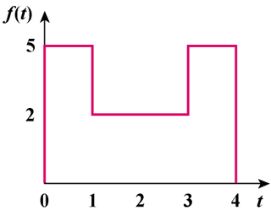

Figure 15.28
For Prob. 15.16.

